ABINAV S T

230701007

EXP NO:5 System Calls Programming

PROGRAM

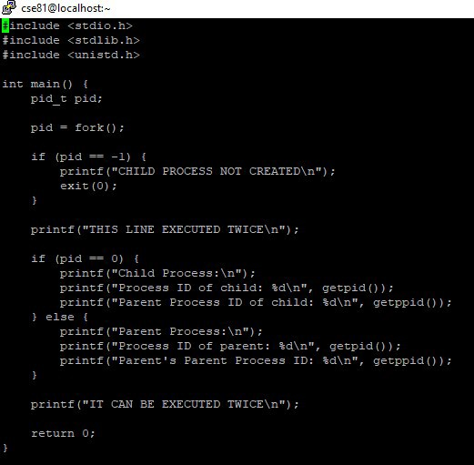

OUTPUT

